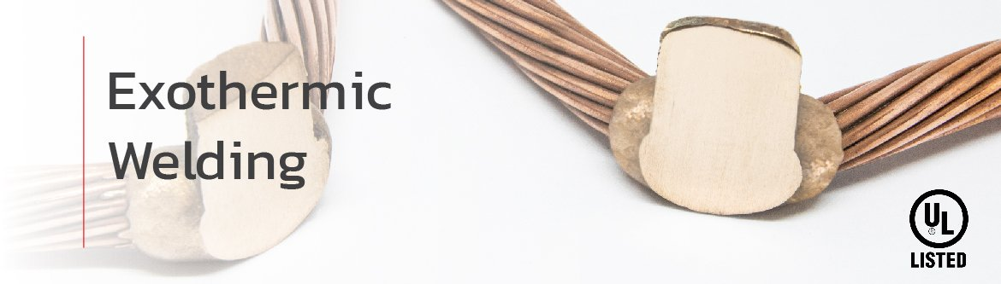

EXOTHERMIC WELDING

Exothermic Welding (a.k.a Thermite or Aluminothermic Welding] is a permanent molecular bonding process in which a chemical reaction between copper oxide and aluminum generates superheat with molten metals reaching high temperatures exceeding 2,600°C (4,000°F).
The process creates a homogeneous, pore-free connection with superior electrical conductivity, exceptional mechanical strength, and long-term corrosion resistance. Suitable for direct burial in soil or concrete, exothermic welds provide a maintenance-free, lifetime connection for critical grounding and bonding applications.

EXAMPLES OF EXOTHERMIC WELDED CONNECTION TYPES

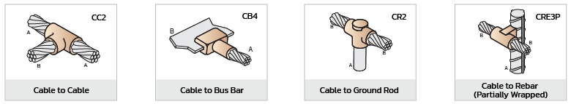

GRAPHITE MOULD
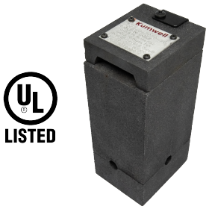
- Kumwell Graphite Moulds are manufactured from high-quality graphite blocks, precision engineered to withstand extreme exothermic temperatures without degrading rapidly.
- Lifespan/Durability: Designed for a minimum of 50 welding operations under normal usage and storage conditions.

WELD METAL POWDER
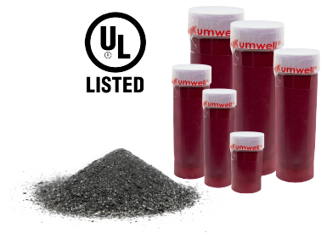
Kumwell weld metal powder uses a specially formulated mixture of metallic powders, primarily copper oxide and aluminum. When ignited, these composite chemicals trigger a high-temperature exothermic reaction, forming a permanent, highly conductive copper alloy joint (typically over 93% copper) Tested & inspected in compliance with global standards UL467, IEEE837, IEC62561-1
- Nontoxic and heavy metal.
- Steady burn without slag, porosity pop or fire out.
- Consistency of color.
HANDLE CLAMPS

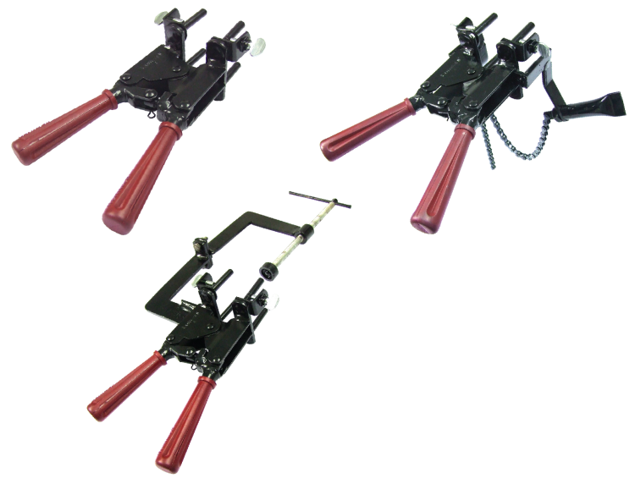
Kumwell Handle Clamps & Support Handles are used for handling / clamping the moulds in vertical position and tightening around the conductor / rebar / ground rod / rail tracks / steel structure etc.., so as to avoid leakage during the Exothermic welding process.

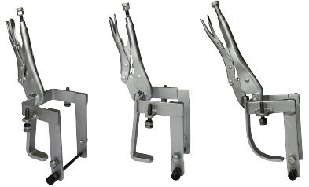

TOOLKIT
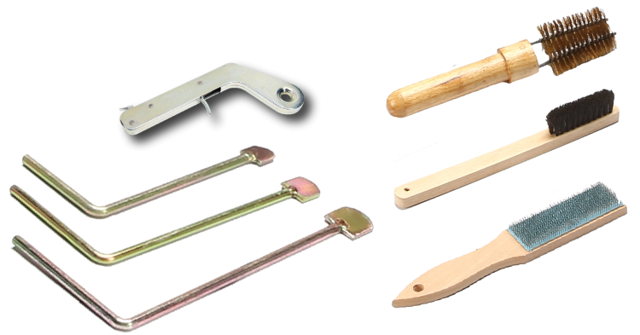
Kumwell Standard Tools are specially designed to support the Exothermic welding process, ensuring efficiency, safety, and reliable performance.
- Flint Ignitor: for starting the reaction
- Cable Clean Brush: for cleaning round conductors and cables
- Mould Brush: for cleaning graphite moulds
- Busbar Brush: for cleaning flat conductors and busbars
- Scraper: for removes slag from the mould after welding
With Kumwell Standard Tools, every weld is performed with greater precision, cleanliness, and long-term reliability

